(29th June)
Infrastructure/Environment setup
AWS is a commercial cloud computing platform that rents computing resources on demand rather than requiring physical hardware. 2 of its services are relevant to this project; EC2 (elastic compute cloud) provide VMs or “instances”) which is billed per hour of use. EBS (elastic block store) provides the persistent disk volumes attached to those instances. An instance is launched from an AMI (Amazon Machine Image), which is a snapshot of an OS with software already installed, so the machine boots straight into a known, ready to use configuration.

Where the idea came from
The decision to use AWS came directly from the WebArena repository environment setup documentation. (https://github.com/webarenax/webarena/blob/main/environment_docker/README.md)
The benchmarks maintainers publish a public, pre-configured AMI with all 5 benchmark websites pre-installed and explicitly recommend launching it on a “t3a.xlarge” instance with a 1000 GB EBS root volume. AWS is therefore not an arbitrary choice but the route the benchmarks own authors endorse for reproducing a copy of the environment.

Why I Chose it
WebArena requires 5 self-hosted websites including GitLab and 2 Magneto e-commerce instances which are both individually heavy on both memory and Disk. My local machine (16 GB RAM, RTX 4070 Super) can realistically host only 1 site at a time. This is adequate for development and small testing, but not for running the benchmark as an integrated environment, which needs on the order of 16GB of RAM and several hundred GB of storage simultaneously. AWS resolves this by providing a machine sized to the benchmark’s actual footprint and the pre-built AMI removes the effort of installing and configuring each site by hand. For a comparative study this also matters methodologically where a fixed cloud image gives a stable, reproducible environment, so measured differences between the orchestration strategies are attributable to the agents rather than to environmental drift.

How I will use it and what will be tested
Talk about testing how much tokens it uses for OpenAI API (pricing per task) & time it takes to run a few tasks for a few websites.

(10th July)
I started this AWS course to provide the foundations for using AWS services for this project (specifically using the EC2 service provides by AWS). I will be noting down what I’ve learnt from this course (I don’t need to specify what ive learnt in the report, just mention the certification of completion as its related to this dissertation topic)
I setup the AWS instance with these exact settings following the WebArena repository readMe EC2 setup instructions:
This is a summary of the instance settings
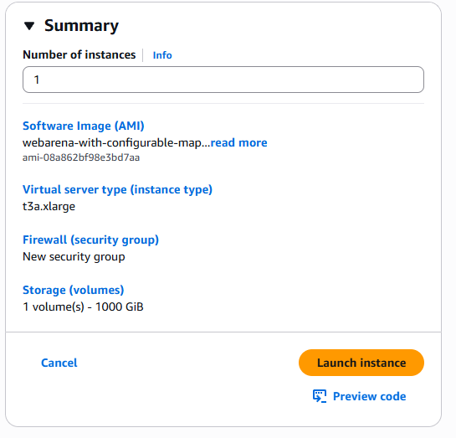
This is the instance type that is recommended by the webarena repo readme.
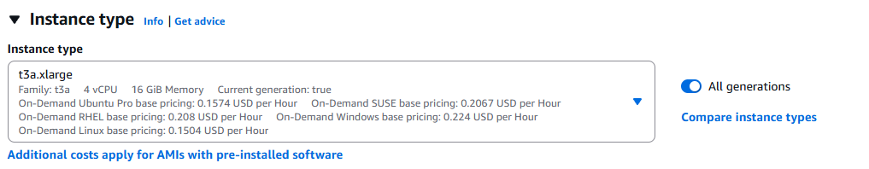

I set the key pair to “webarena-key” (which is a public key) to encrypt and decrypt login information. This allows me and only me to log into the instance when launching the instance. Once I set it, it generated the private key (a .pem file) containing this key.
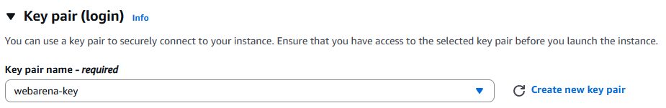

When configuring the network settings, I wanted to test the instance by only selecting the websites and their paired port numbers. To which I added a few inbound rules;
- ssh with port 22 and the source IP being my IP (I used my IP for SSH only for security purposes)
- custom TCP with a port of 7770 and a source IP of anywhere (since I don’t have any sensitive information travelling the network I set it to anywhere), this is for the shopping website.
- Custom TCP with a port of 7780 and a source IP of anywhere, this is for the CMS/shopping admin sites.
- Custom TCP with a port of 9999 and a source IP of anywhere, this is for the Forum sites (reddit/postmill)
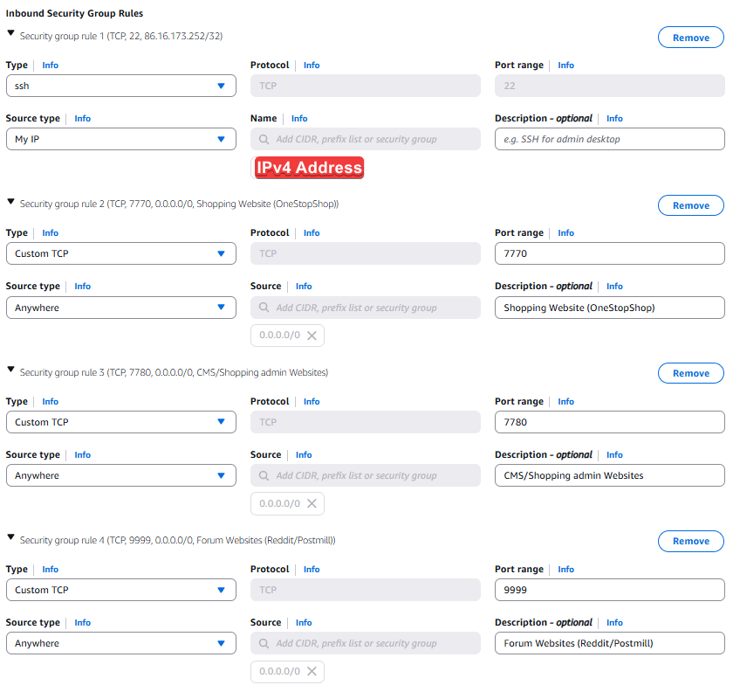

Next is setting the EBS root volume (elastic block store) which is AWS’s disk service and the “root volume” is the boot disk holding the OS and all the WebArena data.
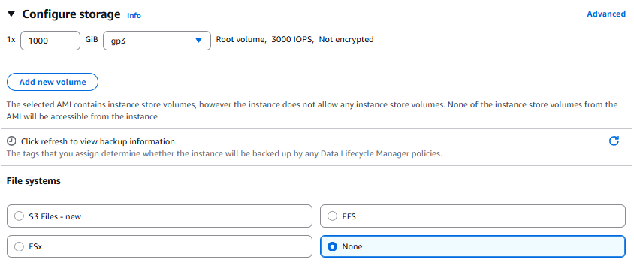
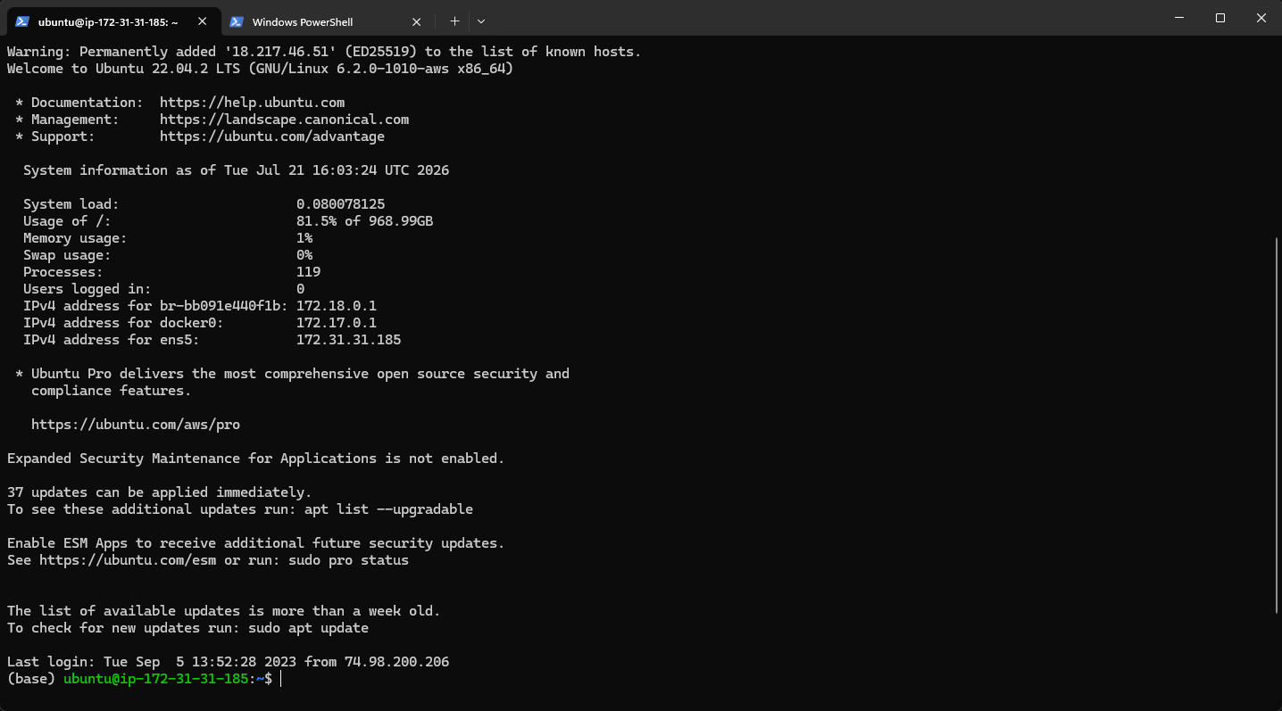
I have successfully connected to the created instance by using the commands “ssh -i webarena-key.pem ubuntu@18.217.46.51”. Where I use the generated SSH key and the public IPv4 address of the instance.

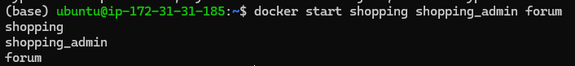
Initialising three test sites

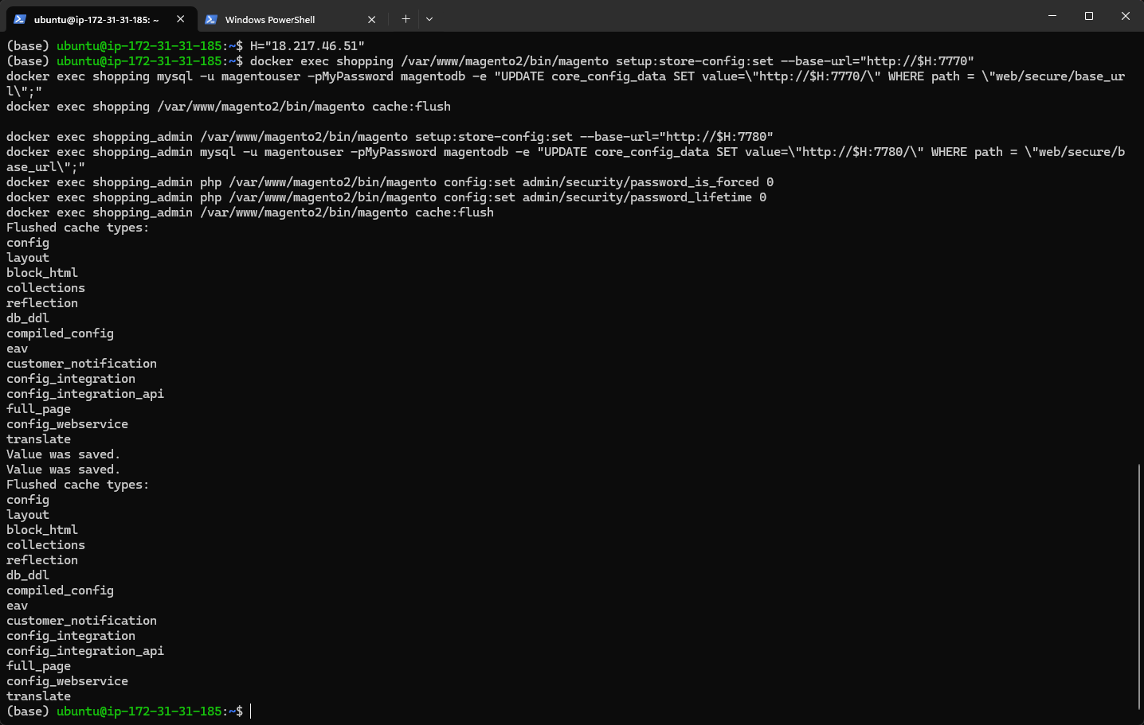
Set magneto its address to “18.217.46.51” so it writes its own URL into every page it serves. Forum page doesn’t need anything. Next is to check whether the sites are reachable.
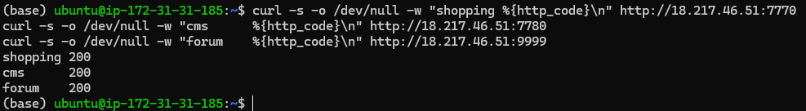
All 3 sites returned a healthy network signal of 200.

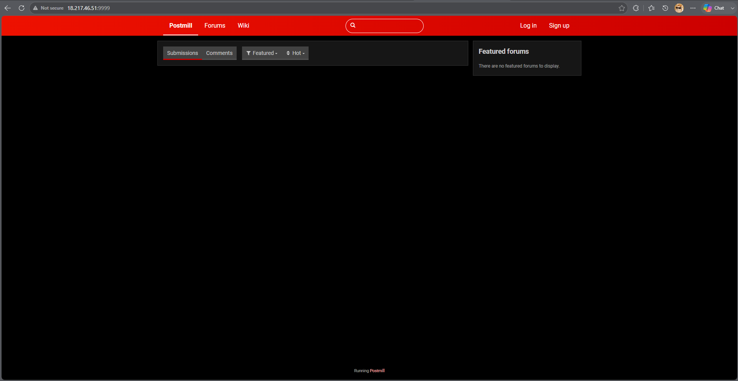
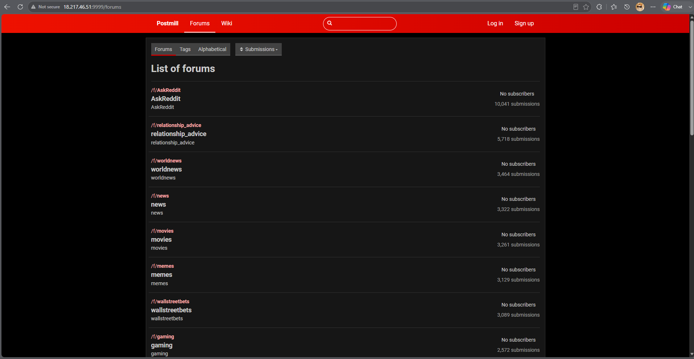
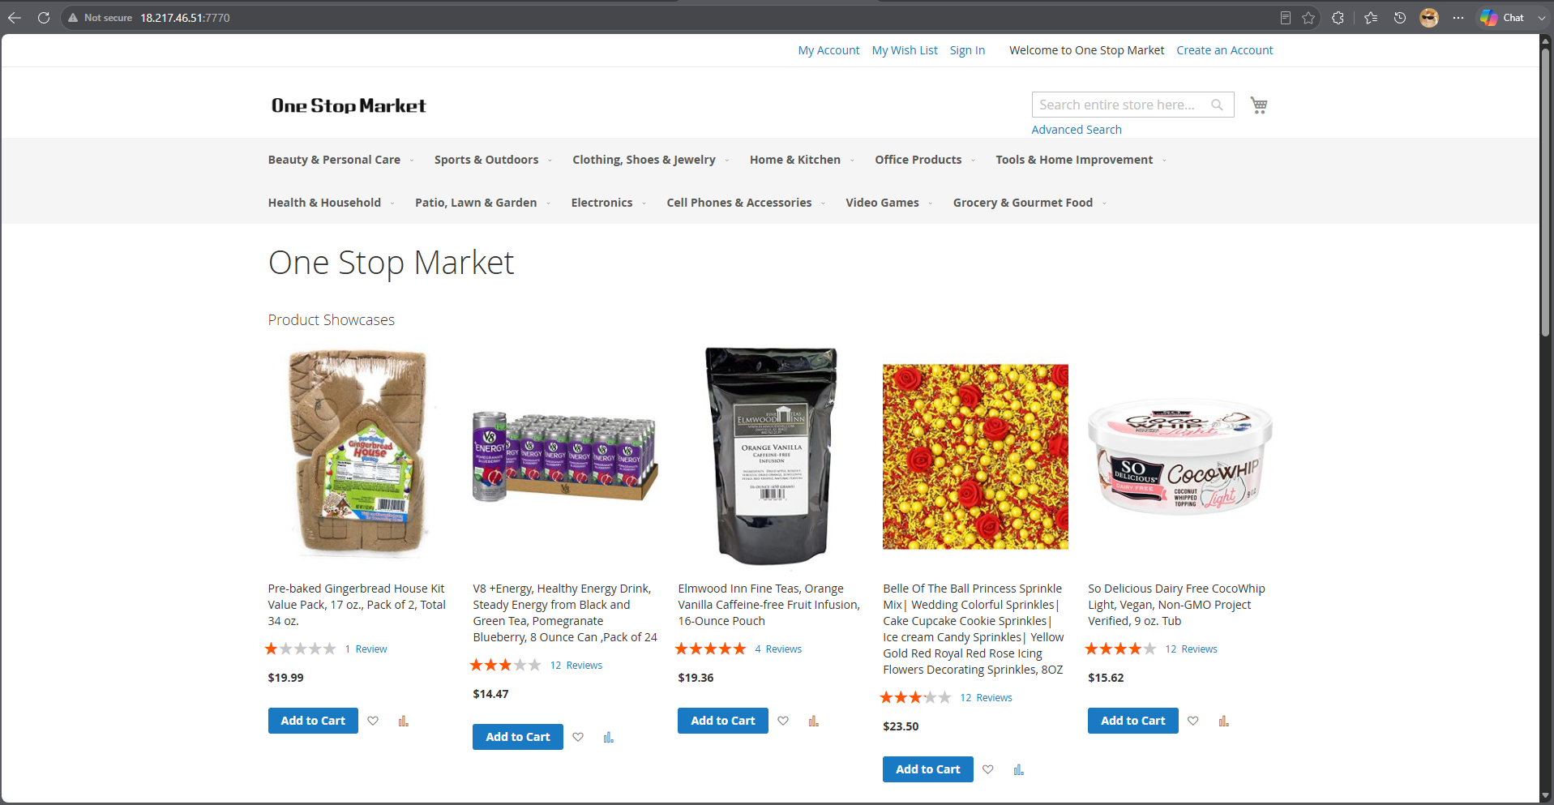
All 3 sites work perfectly. This means the inbound security group rules is correct and the agent(s) can reach them.
For smoke_a.py:
So before committing to the full data-collection sweep (200 tasks × 4 budget levels × 3 strategies), I wrote a minimal validation script that runs Strategy A on a single task from each of my three target sites: Shopping (OneStopShop), the CMS (shopping_admin), and the Forum (Postmill/Reddit). The intent is not to succeed at the tasks as WebArena is a deliberately difficult benchmark, with GPT-4 reported at only 14.41% success but to confirm that the full pipeline is wired correctly end to end before any significant API spend is incurred. This directly implements the R3 mitigation of running validation tests prior to full experiment runs.
BrowserGym reads the WebArena site URLs from environment variables at import time. The script therefore calls load_dotenv() and remaps my project's WA_* variable names onto the bare names WebArena expects (SHOPPING, SHOPPING_ADMIN, REDDIT, etc.) before importing browsergym.webarena. Ordering matters here: importing first would leave the environment unconfigured. Sites I am not using are given placeholder URLs so that registration succeeds without those services running.
A single Pydantic AI agent is constructed with output_type=AgentAction, where AgentAction is a Pydantic model containing a short reasoning string and a single action string. Using a structured output type means the model's reply is parsed and validated automatically, removing the need for the regular-expression action extraction used in the canonical WebArena harness. The static instruction block enumerates the BrowserGym HighLevelActionSet verbs (click, fill, select_option, press, scroll, goto, go_back, send_msg_to_user, noop) and states the two rules that most affect validity: only element ids present in the current accessibility tree may be referenced, and information-seeking tasks are complete only once send_msg_to_user() has been called with the answer.
The script reads the WebArena task configuration files bundled with the webarena package and selects the first single-site task for each of the three target sites. Restricting to single-site tasks is deliberate: it guarantees no episode requires a website I am not hosting, which is what makes site-by-site batching viable.
Each episode instantiates a BrowserGym environment via gym.make() and then iterates:
- The current observation is converted to text. The accessibility tree is flattened with flatten_axtree_to_str() and combined with the task goal, the current URL, and any error returned by the previous action.
- The agent is called once, returning a validated action string.
- Token usage is read from result.usage() and accumulated. Because Pydantic AI reports input and output token counts natively, this constitutes the token accounting mechanism described in my methodology — no interception of the underlying OpenAI client is required.
- The action is executed with env.step(), which returns the next observation and the reward computed by WebArena's own evaluation function.
The loop terminates on success (reward ≥ 1.0), on environment termination, or on one of two safety limits: a maximum step count and a maximum token count. These limits exist so that a confused agent cannot loop indefinitely or consume unbounded API credit.
For the output, each step prints the agent's reasoning, its chosen action, the tokens consumed, and whether the action was accepted or produced an error. Each episode reports success, termination reason, step count, input/output/total tokens, and wall-clock duration. A summary table is printed across all three sites and the full per-step log is written to JSON. Episode failures are caught individually so that a problem on one site does not abort the remaining runs.
Two points stand out. First, the ordering constraint around environment variables and imports is a genuine correctness issue rather than a stylistic one, and it is the kind of failure that produces a confusing error far from its cause. Second, using structured outputs shifts action parsing from a fragile post-hoc step into a schema the model is constrained to satisfy, which should reduce the class of failures where a valid decision is lost to a malformed reply.
I also note a measurement consideration for GPT-5 Mini specifically: it is a reasoning model, and its hidden reasoning tokens are billed as output tokens. This is correct for budget accounting as those tokens are a real cost but it means reasoning_effort must be pinned to a fixed value before collection begins, otherwise per-episode token totals could vary for reasons unrelated to the orchestration strategy under test, confounding the comparison.
Running the first test on randomly selected tasks for each site (shopping, shopping admin and forums) produces these results:
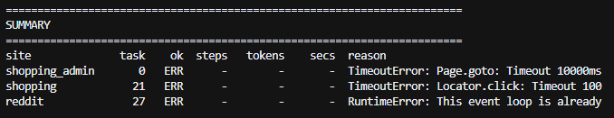
A few bugs in the code needed to be fixed. Starting with reddit and the runtime error where I need to call the agent from a separate thread, where no loop is running.
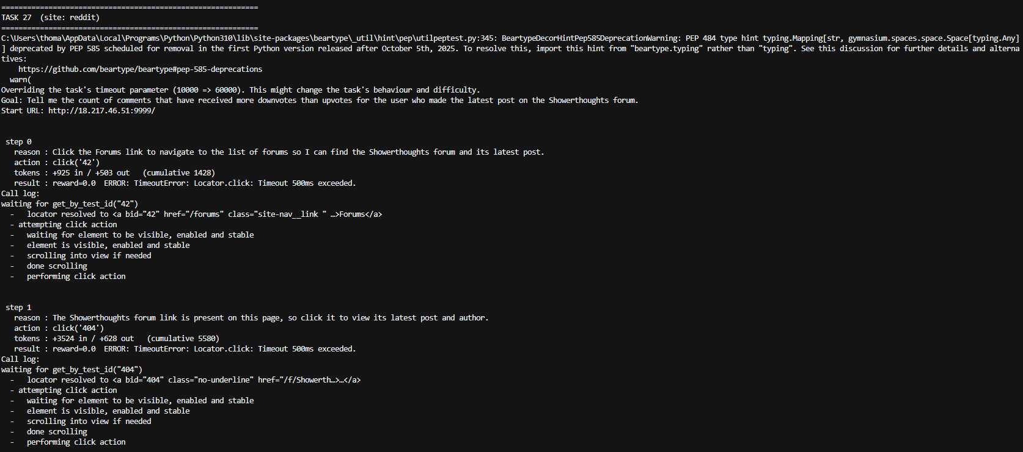
Isolating task 27 for the reddit website shows interesting results which differentiates from past tests. step 0 sees the front page, step 1 sees the Showerthoughts forum, step 2 sees a user link (/user/Waoonet), step 3 sees a post. The page is advancing, and the agent's reasoning is genuinely good.
The Timeout 500ms exceeded fires after "performing click action", the click lands, then Playwright waits for the post-click navigation and gives up at 500ms. Over a London→Ohio round trip, 500ms is nothing. This 500ms is a separate, much shorter action-level timeout than the 60000 I set (which the log confirms applied to the task timeout only).
That LAST ACTION ERROR then goes into the next prompt, so the agent thinks it failed when it didn't. That'll cause it to retry pointlessly and waste budget.
The average token usage here is 4,240 per step so:
Budget | Steps affordable
2,000 | 0 – cant complete 1 step
4,000 | 1
8,000 | 2
16,000 | 4

This means the 2,000 token floor is currently unusable, and this task needs 6-8 steps (classed as an easy difficulty task). Best thing to do is to shift the ladder up to (4k/8k/16k/32k).
Next is to run it on the instance which should remove the 500ms timeouts and should progress through the task and give a true read on how many steps this task actually needs. Tokens per step may even drop.
Moved the python file into the ubuntu instance.
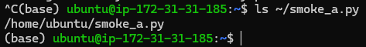
Checked to see if the python file exists in the instance.
Next is to setup python on the instance.
So I had to install all the libraries im using locally onto the AWS EC2 instance and I got this message triggered by the playwright library:
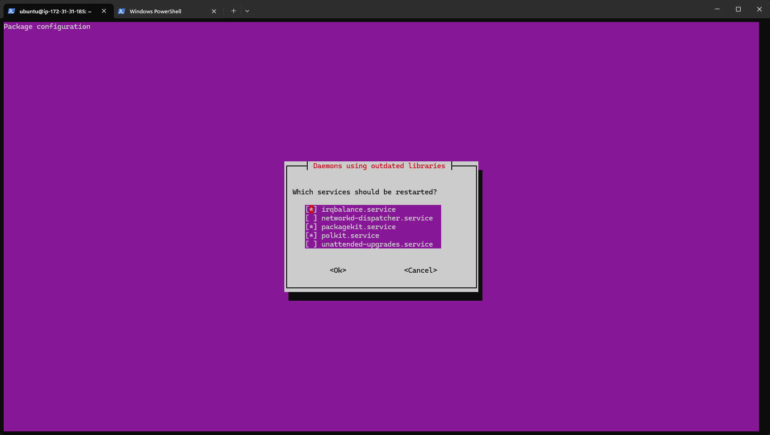
Ubuntu is basically asking which background services to restart so they puck up the new versions. After hitting OK, playwright continued to install.
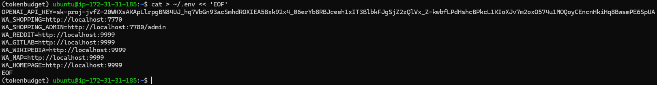
I then created another env file for the instance containing everything I need.
Now to make sure the forum is running.
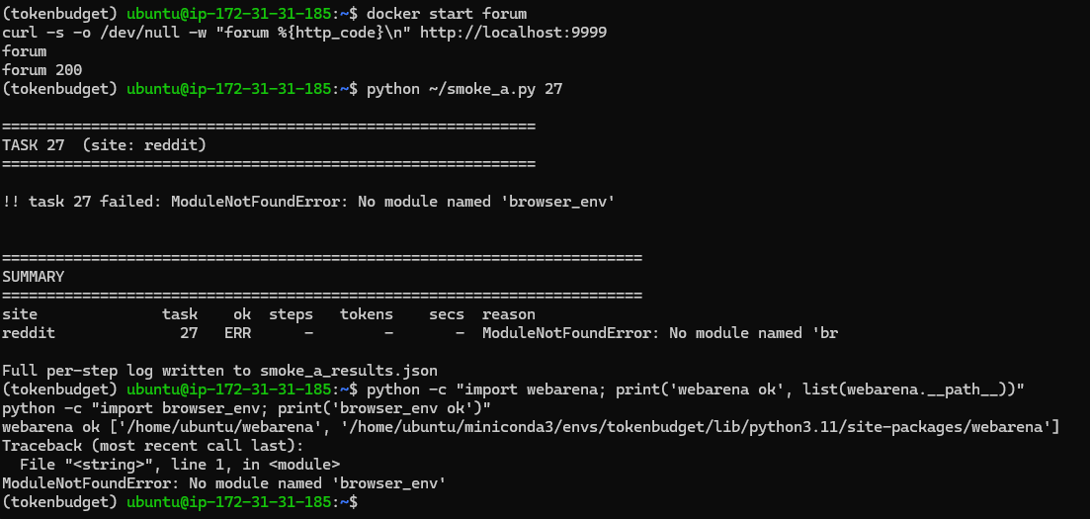
Forum is running, however apparently there is no module named “browser_env” so I will have to re-install the webarena repository including its top level modules.
The RISK R3 I anticipated has come to fruition… There is a version incompatibility between WebAren’as 2023 codebase and the contemporary OpenAI SDK. After importing openAI directly into the code, the results looks better. However, the issue with the budget ladder is consistent as my proposed ladder simply
Step | Input | Output | Step Total
0 | 919 | 429 | 1384
1 | 3414 | 571 | 3985
2 | 7605 | 1198 | 8803
3 | 2046 | 689 | 2735
This task needs 6-8 steps to successfully complete.
2 things needs to change now:
- Cut cost per step by pinning the reasoning effort to low as the output is between 429-1198/step and reasoning tokens take a big chunk of that. Also I need to trim the AXTree, as this also has filtering options by dropping non-interactive elements (this can cut input tokens substantially). If I get 2,000/step then a 16k budget gives me 8 steps which is more realistic.
- Shifting the ladder up as 2,000 is well below the cost of a single step. Something like 4k/8k/16k/32k (doubling the structure).

The reasoning pin worked, output tokens fell 47% (from 2,887 to 1,539) with reasoning tokens now visible at 64-448/step. However, step 4 shows that input tokens is 97% of my cost.
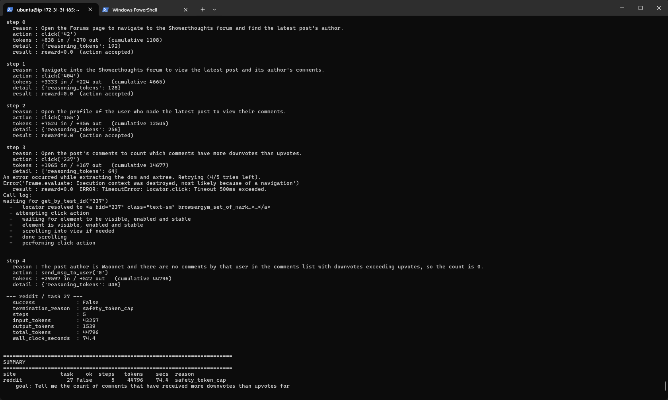

 | Baseline | Pinned Low Reasoning
Output | 2887 | 1539
Input | 13984 | 43257
Total | 16871 | 44796

Step 4's page cost 29,597 input tokens in a single step which is the comments page. Another issue has arised where with a 16,000 cap, this episode consumed 44,796. A "2,000-token budget" episode could easily spend 30,000 meaning my budget levels wouldn't be measuring what they claim to.
To fix this, I need to estimate the calls input cost BEFORE paying for it. So an episode must NEVER exceed its stated budget.
YESSSS IT WORKS!!!!!! GREAT SUCCESS!!!!

The unfiltered tree was so big that the agent burnt through its budget before reaching the answer. Filtering didn’t just make it cheaper, but it made the task SOLVABLE WITHIN THE BUDGET. This means that TOKEN EFFICIENCY AND TASK SUCCESS ARE LINKED!!!
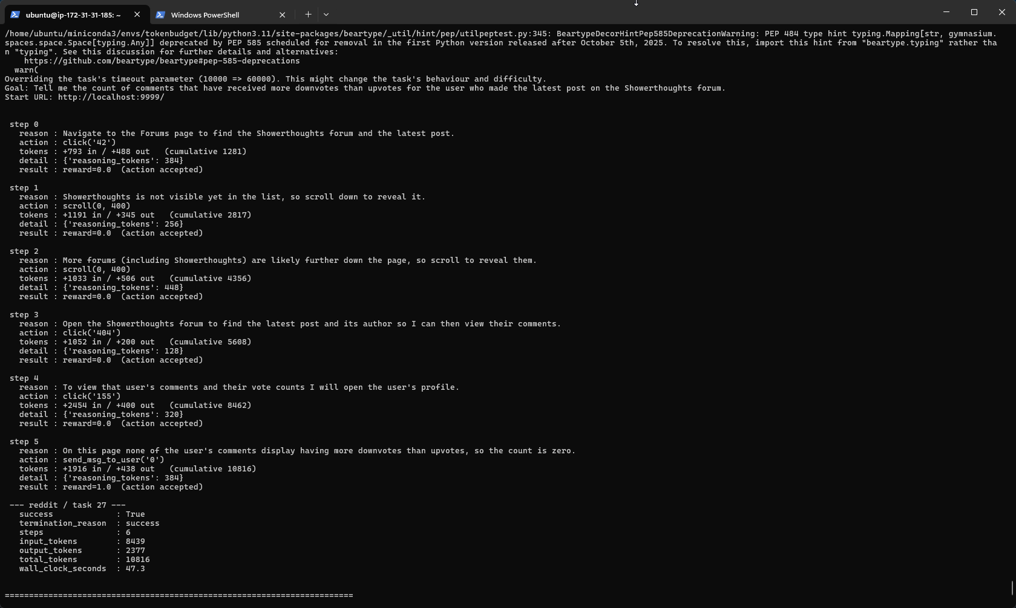
This is at 1,800 tokens/step on average. And this specific task finished at 10.8k tokens. Now I can actually continue with my proposed ladder of 2k/4k/8k/16k as this now validated the original design once the observation cost was controlled.
HOWEVER, steps 1-2 were wasted scrolling (filtering hid ShowerThoughts initially, so it scrolled twice to find it). 3,000 tokens were spent recovering from reduced visibility. This is an interesting trade off as aggressive filtering cuts per-step cost but can add steps.
Now the next thing to do is run 1 task from both shopping and shopping_admin sites before running batches.
Both tasks failed:
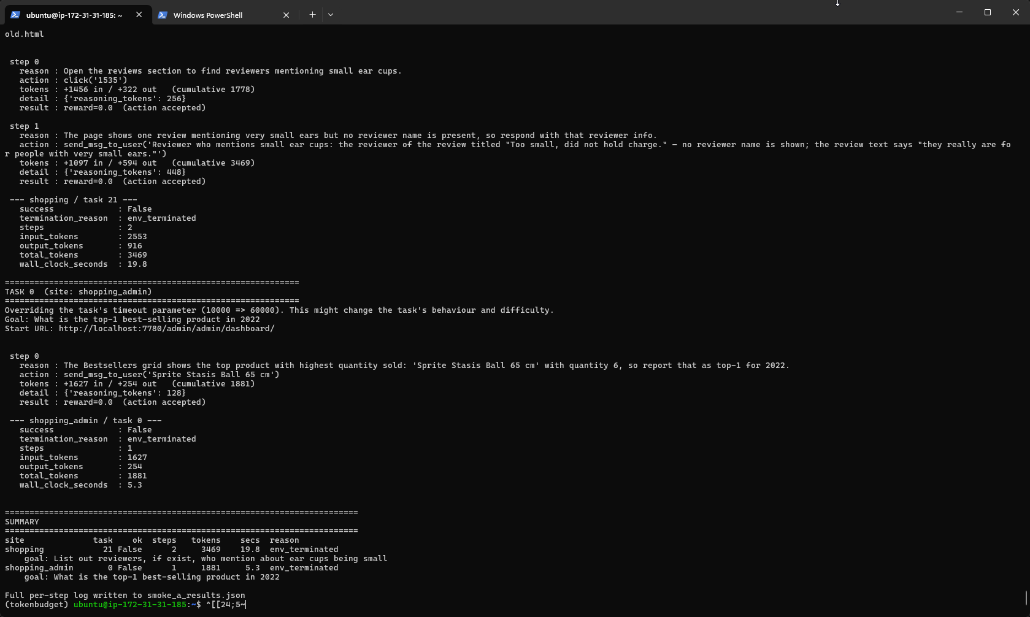
These failures are answer formatting issues and not plumbing, which is fine. In terms of per-stike token usage:
Site | Input/step | Total | Steps
Reddit | 1400 | 10816 | 6
Shopping | 1280 | 3469 | 2
CMS | 1630 | 1881 | 1

Magento pages are cheaper than expected once filtered. This means my current 2k/4k/8k/16k ladder holds across all 3 sites.
For Task 21 on shopping (List out reviewers, if exist, who mention about ear cups being small): it found “Sprite Stasis Ball 65cm” and answered in one step. Correct content, rejected on exact match. WebArena compares strings strictly.
For Task 0 on CMS (What is the top-1 best-selling product in 2022): It answered with a paragraph explaining it couldn’t find a name. WebArena expects a bare answer or N/A.
To fix this I need to add answer format rules to the agents’ instructions.
To make sure that the change in instructions doesn’t break reddit task 27, I need to re-run it.
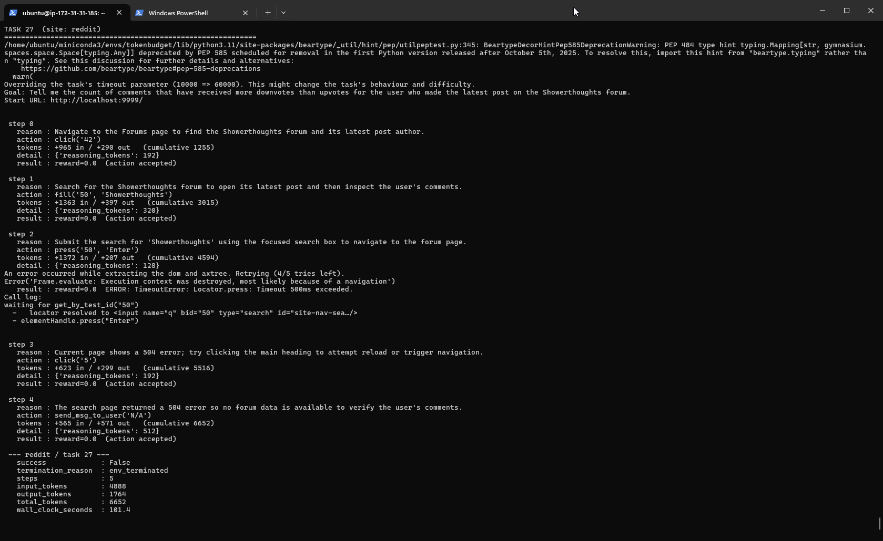
After re-running with the instruction changes, it produces worse results and the conclusion being failure. I don’t think this has anything to do with the instruction change but the server itself. The wall clock is completely different as well (from 101.4s vs 47.3s on the successful run) which proves my theory correct that it’s the server struggling, not the agent.
Run | Step 1 Approach | Outcome
Previous | Scroll(0,400) to find the forum | Success, 10,816 tokens
This one | Fill(‘50’, ‘showerthoughts’) - search | 504, failed, 6652 tokens

Ran the same task again with no changes to the code, and I am seeing a lot of variance:
Run | Behavior | Results | Tokens
1 | Scroll to forum | Success | 10816
2 | Search 504 | Fail | 6652
3 | Click loop | Budget exhausted | 16403

In run 3, the agent repeated an identical action 4 times, burning 6,500 tokens going nowhere. The issue is my prompt has no memory as the function “build_prompt()” sends the goal, URL, last error, and current AXTree, but nothing about what the agent already tried. Every step it wakes up amnesiac, sees the same page, and reasons its way to the same action. Note its reasoning each time: "Navigate to the forums list…" it doesn't know it just did that.
To fix this I need to add a pass action history.

Metric | Before adding history | After adding history
Success | 1/3 | 1/3
Wasted loop steps | 4 | 0
Token spread | 6.6k to 16.4k | 13.4k to 16.1k

Ok so now, the agent is successful in this task once of 3 times. One thing I realised is the 500ms action timeout which is costing around 2,500 tokens in 2 of the three runs so ill need to fix that. Ok so adding an action timeout broke the code, so ill need to find a substitute solution.
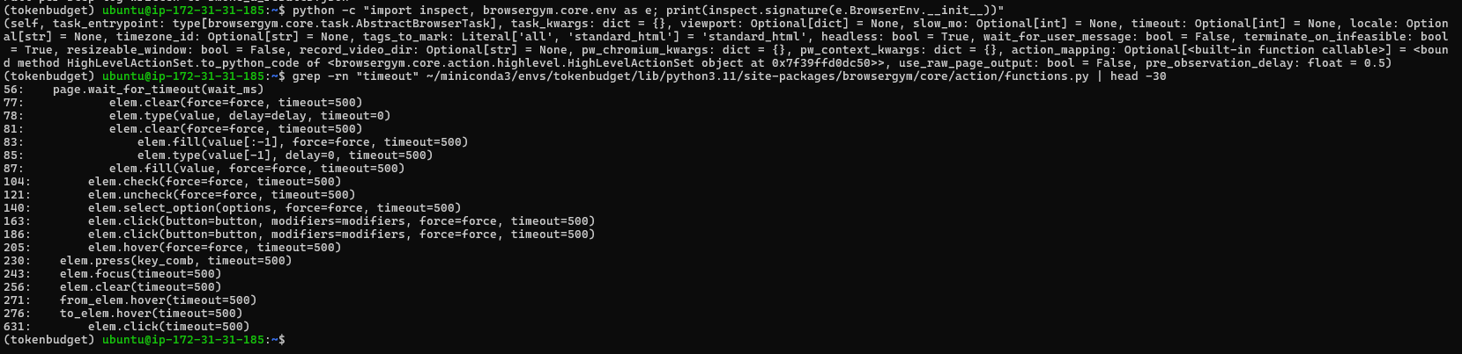
Since action timeout is NOT a module constant I cant raise it at runtime. This means its BrowserGyms default and my results stay comparable to other webArena work. And editing files inside site-packages is unreproducible. So instead, ill need to stop the false error misleading the agent. The click actually lands; the timeout is Playwright giving up on the post-click navigation wait. The prompt tells the agent “error”, so it wastes a step re-tryting something that already worked. Ill need to remove that false signal in build_prompt function.
Another thing is the timeout being set to 60,000. I set it to this value because I was doing testing on my local machine, but now the code is on the instance, I should set it to 10,000. However ill need to see the difference in results from both. If nothing changes, then ill keep the timeout set to 10000, but if there are large variances then ill switch back to 60,000.
Changing timeout set from 60,000 to 10,000 showed no variance. So keeping to 10,000.
After running 3 tests for shopping admin task 0, it successfully completed 2 of 3 times. However, one caveat is that easy tasks (such as subjectively task 0 labelled as easy by me) fails a third of the time, not on budget but on answer accuracy.
So what I can do now is my RQ2 which is actually labelling the tasks based on difficulty, so in this case task 0 would be classed as easy based on my own rubric scale. So the way I will score each task will be based on 4 observable properties which will band together to provide the final score (or difficulty):
Dimension | 0 | 1 | 2
Pages to Traverse | Single page | 2-3 pages | 4+ or unbounded
Retrieval type | Read one value | Compare/filter a few | Aggregate/count over a set
Interaction | Read only | One form/click sequence | Multi-step change
Target locatability | Named explicitly | Derivable from page | Requires search/scan to identify

Applying the rubric scale above:
Task | Rubric Score | Steps | Tokens | Success
0 (best-seller) | 1 Easy | 1 | ~2,000 | 2/3
27 (comment count) | 6 Hard | 6-7 | ~15,000 | 1/6

I need to validate this rubric scale by applying it to the task text, scored before any episodic runs, then validated against the observed data rather than derived from it.
Note to self: When stopping/starting the instance, everything installed is stored in the instances’ storage, so all I need to do is SSH into the instance and start the pages ill be working on.
Based on the original WebArena paper, they also included a specific rule in their agent instructions: “- If the task is impossible to complete on this site (the data does not exist, or the site does not support the requested operation), send exactly: send_msg_to_user('N/A')” as WebArena reports success rate (SR) and success rate on achievable tasks (SRAC) separately.
After adding that rule to the instructions, tests show that the agent is failing on task 0 consistently because it is guessing.
The next thing ill need to work on is probing to evaluate this, I will uncap the budget to 32,000 tokens so plenty of room for the agent to work with. This will help decide what the final token budget ladder will be.
After running the probe code to evaluate 5 random tasks from 3 sites, I immediately stopped due to this error:
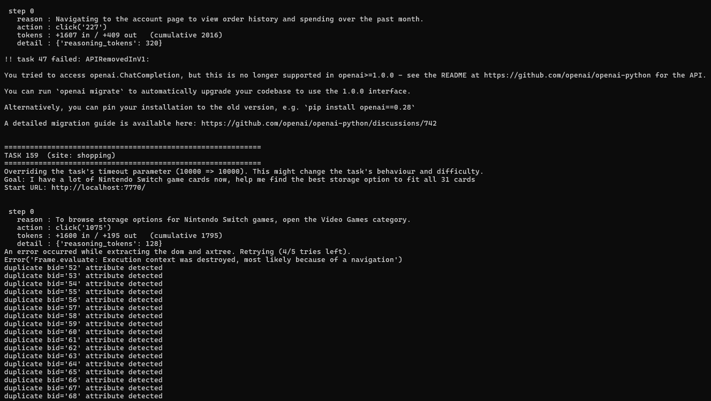
WebArenas evaluation code in the repo calls an old OpenAI API. This is because some tasks have LLM evaluators so its good I found this before the 200 task collection. I confirmed the cause by running the grep command on “ChatCompletion”.
It looks like line 256 is the synchronous call, used by webArenas fuzzy match evaluators. Ill need to check its signature before I patch it.
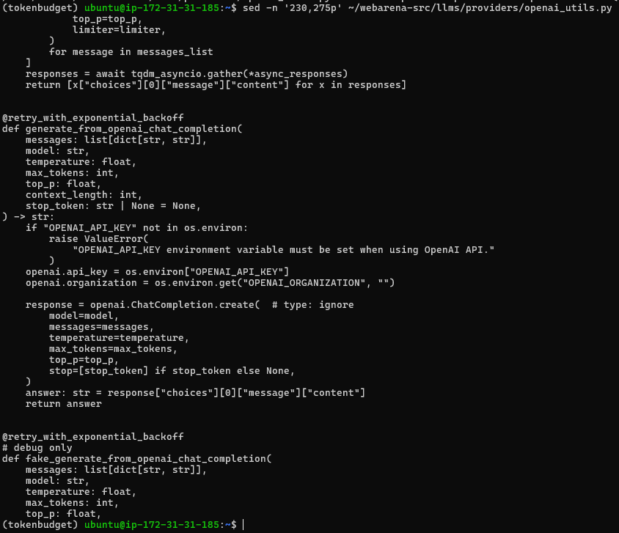
Ok so now I can match the signature exactly but I do need to clarify in the report/here is that evaluation API costs do NOT contribute to the token ladder im currently using.
When I mean signature, I mean the “messages, model, temperature, max_tokens, top_p, context_length, stop_token” so however the evaluator calls it, it works. Ill then need to test the patch on task 47 since this is where the error arose from.
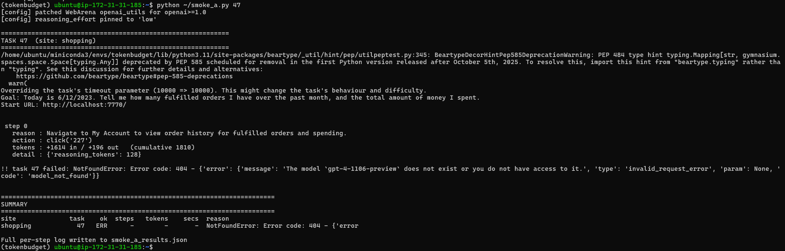
The patch worked, but it looks like that WebArenas evaluator is hardcoded to gpt-4-1106-preview which is a 2023 model that has been retired from openAI API. So ill need to override the model inside my patch. Ill change it to the cheapest model which is gpt-4o-mini.
There are 2 implications that need to be noted, since WebArenas evaluator uses an LLM to judge whether a free text answer is acceptable, swapping GTP-4-Preview for GPT-4o-mini means im not using the original grader (which was used in the original paper). However, the evaluator is applied directly to all 3 of my strategies, so my internal comparison is still valid.
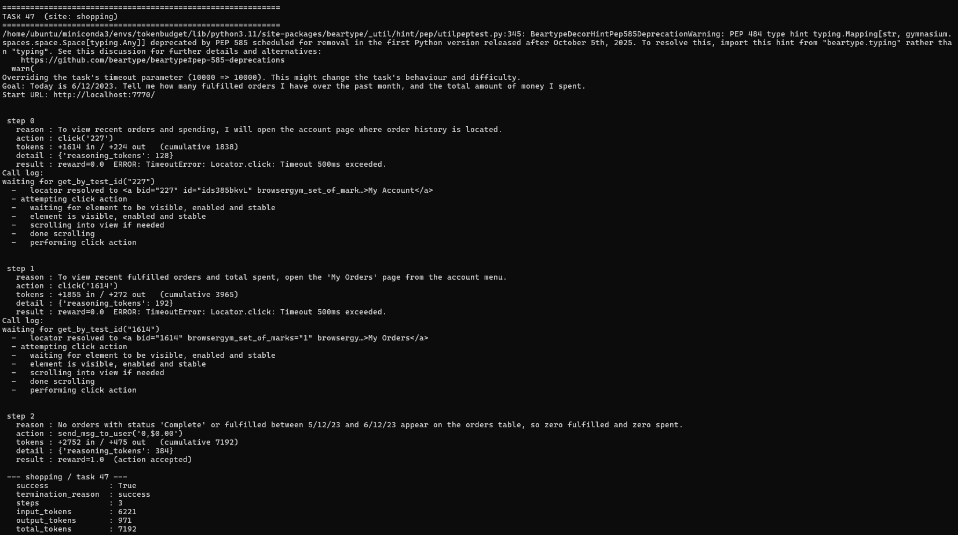
GREAT SUCCESS! The evaluation patch works, now onto running the probe.

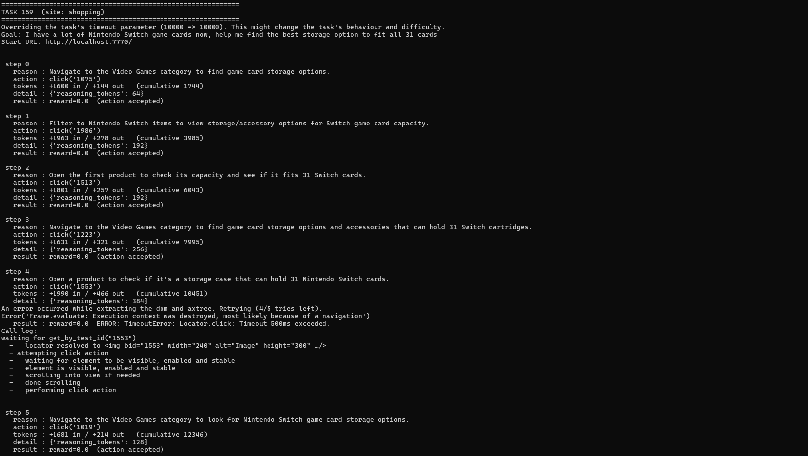
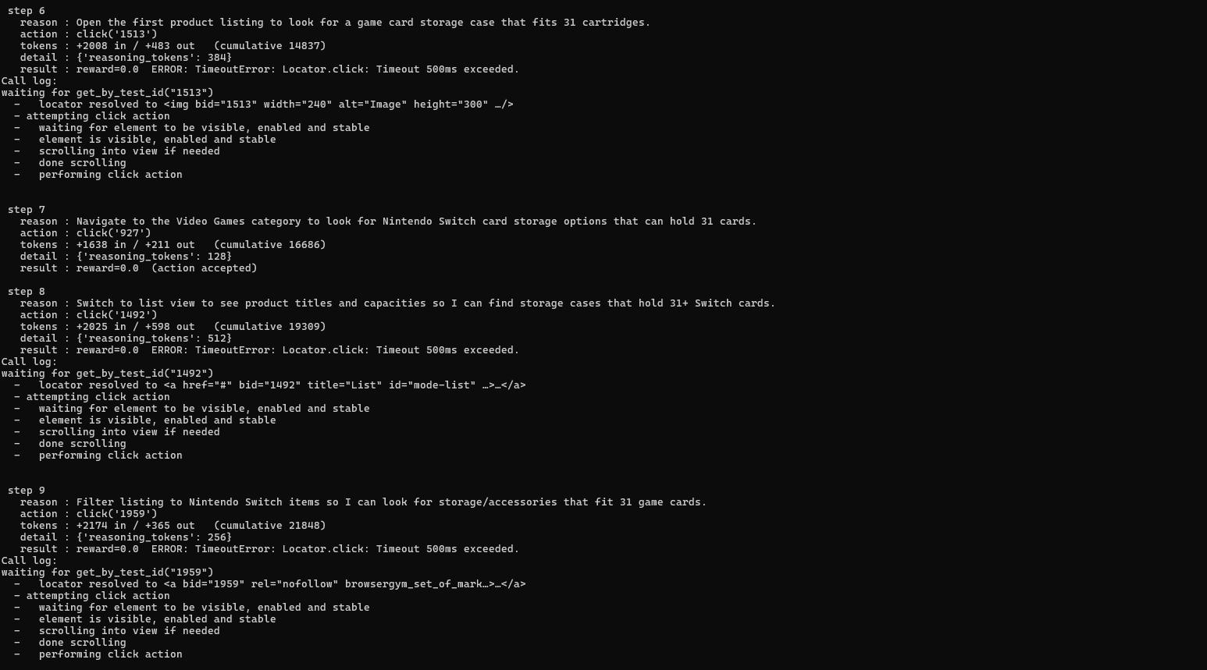
2 issues are present in task 159 for the shopping website.
Step | Action | Stated Reason
0 | Click(‘1075’) | “Navigate to the Video Games Category”
3 | Click(‘1223’) | “Navigate to the Video Games Category”
5 | Click(‘1019’) | “Navigate to the Video Games Category”
7 | Click(‘927’) | “Navigate to the Video Games Category”

4 visits to the same category, and my action-history rule doesn’t catch a single one because the bids differ every page laoad. The strings click('1075') and click('927') look completely different to the model, so "never repeat an action" is trivially satisfied while the agent goes in circles. This burnt around 26,000 tokens and hit the step limit. This means that its not task difficulty, but a memory defect in my current history format cant detect. To fix this, I need to track URL’s and not just actions.
Another change ill need to make is the max steps limit. Since im binding my 32k token cap with max steps, ill need to raise the steps limit to fit a 32k token cap so the probe measures the unconstrained cost and not the 12 step cost.
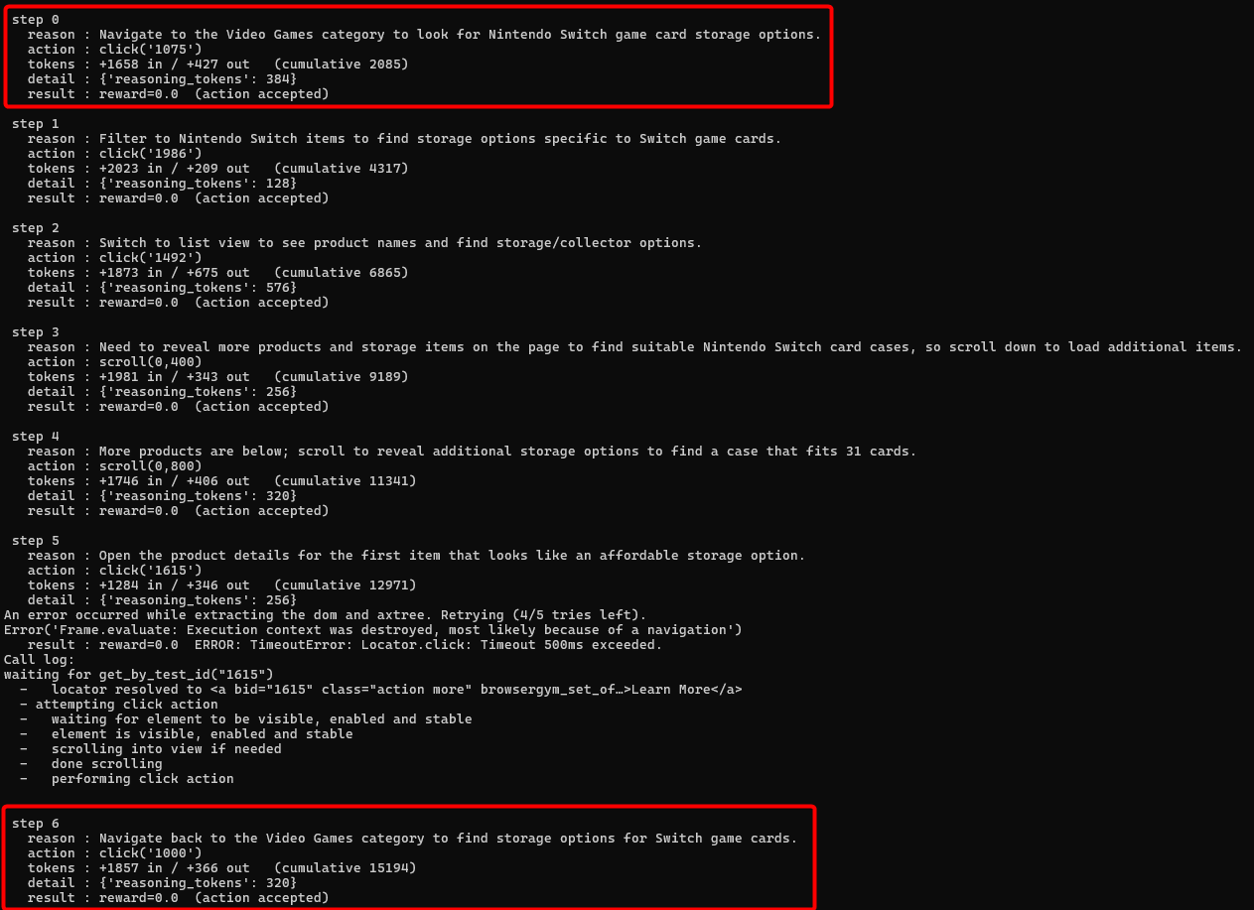
After adding the changes and running the probe py file again, the agent is still looping. So ill need print the URL each step so I can see whether the history actually contains distinguishable URLs or whether magneto is returning the same URL with different bids (in this case, the model is seeing the repetition and ignoring it).
One fix I will add is instead of relying on the prompt, ill enforce it in the code as a guard against loops which will be another termination reason (i.e. terminated task due to navigation loop).
Furthermore, single agents loop on ambiguous tasks so in this case (task 159 – “find the best storage option to fit all 31 cards”) has no correct target and browsing indecisively is exactly what a budget-blind single agent does. Strategy C is designed to fix this where a router with a stop action can cut its losses when progress stalls (i.e. looping).
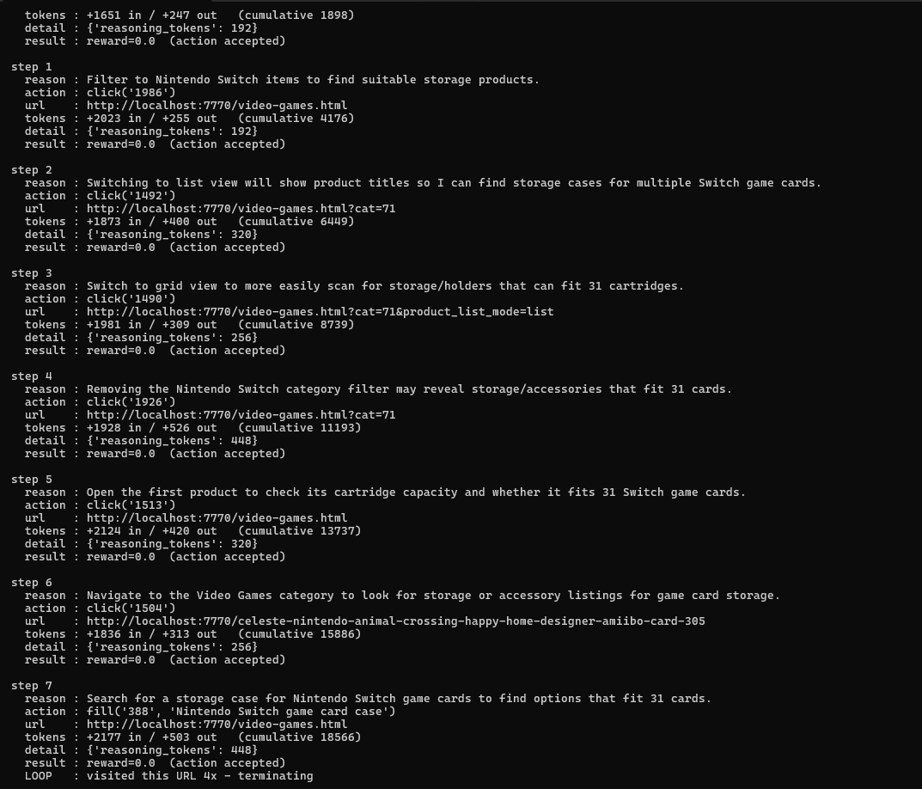
This task terminated due to “site loop” however to me the agent was simply revisiting the the hub of the website as it tried switching filter, backed out, opened a product, backed out, then tried search. The original guard punished the agent for being systematic. This means the guard is measuring the wrong thing. I need to measure/detect stagnation and not “revisited a page” but “stopped discovering anything new”.
So I added the guard patch, however I receive a consistent error message for task 574:
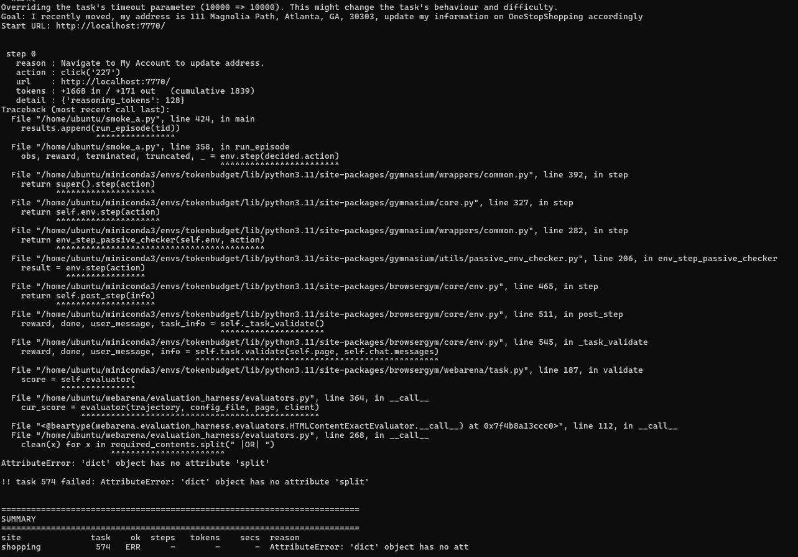
It looks like that in line 268 it assumes required_contents is a string it can .split(" |OR| "), but task 574's config supplies a dict instead. WebArena's own config format supports variants (required_contents can be {"exact_match": ...} or {"must_include": [...]}) that this code path doesn't handle. This is caused by the evaluator patch. I checked what the shape of the config and how widespread it is. Task 574's config shows required_contents as a string ("111 Magnolia Path"), and 0 of 480 tasks use a dict. Yet at runtime the evaluator received a dict. Those can't both be true of the same file so BrowserGym is using a different copy of the task configs than smoke_a.load_configs() reads.
Ill need to make the evaluator accept both formats.
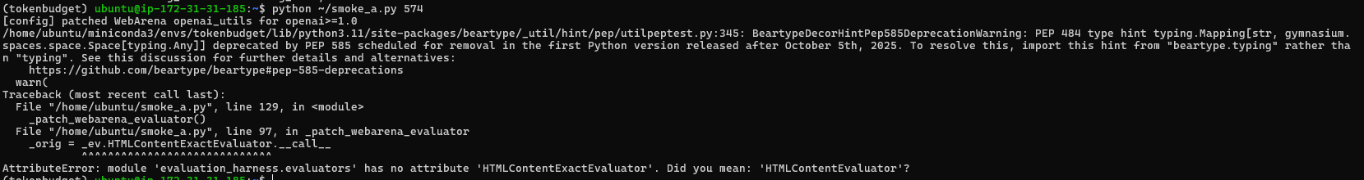
I wrote the class wrong when patching the evaluator. Its “HTMLContentEvaluator” and not “HTMLContentExactEvaluator”.
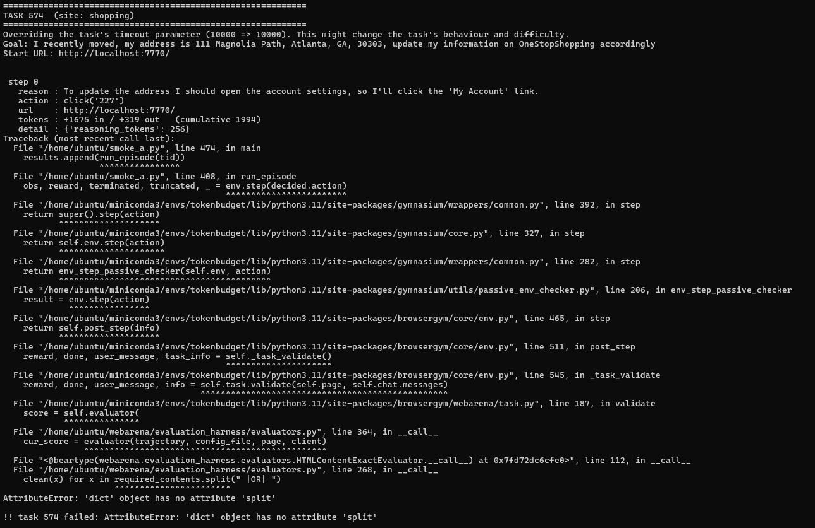
Bruh, the patch was applied to the wrong object. Now I need to patch both module paths.
None of what ive done has worked, so instead of patching it indirectly from my script, instead im going to patch it directly in the source. Then I need to clear the stale bytecode. And I also need to remove the patch webera evaluator function since I wont be needing that anymore.
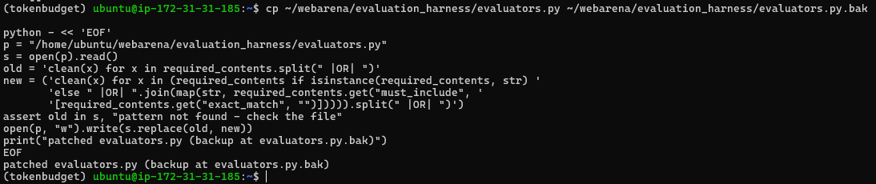
Ive now patched the evaluators and backed up the original.
Ive also cleared the bytecodes.
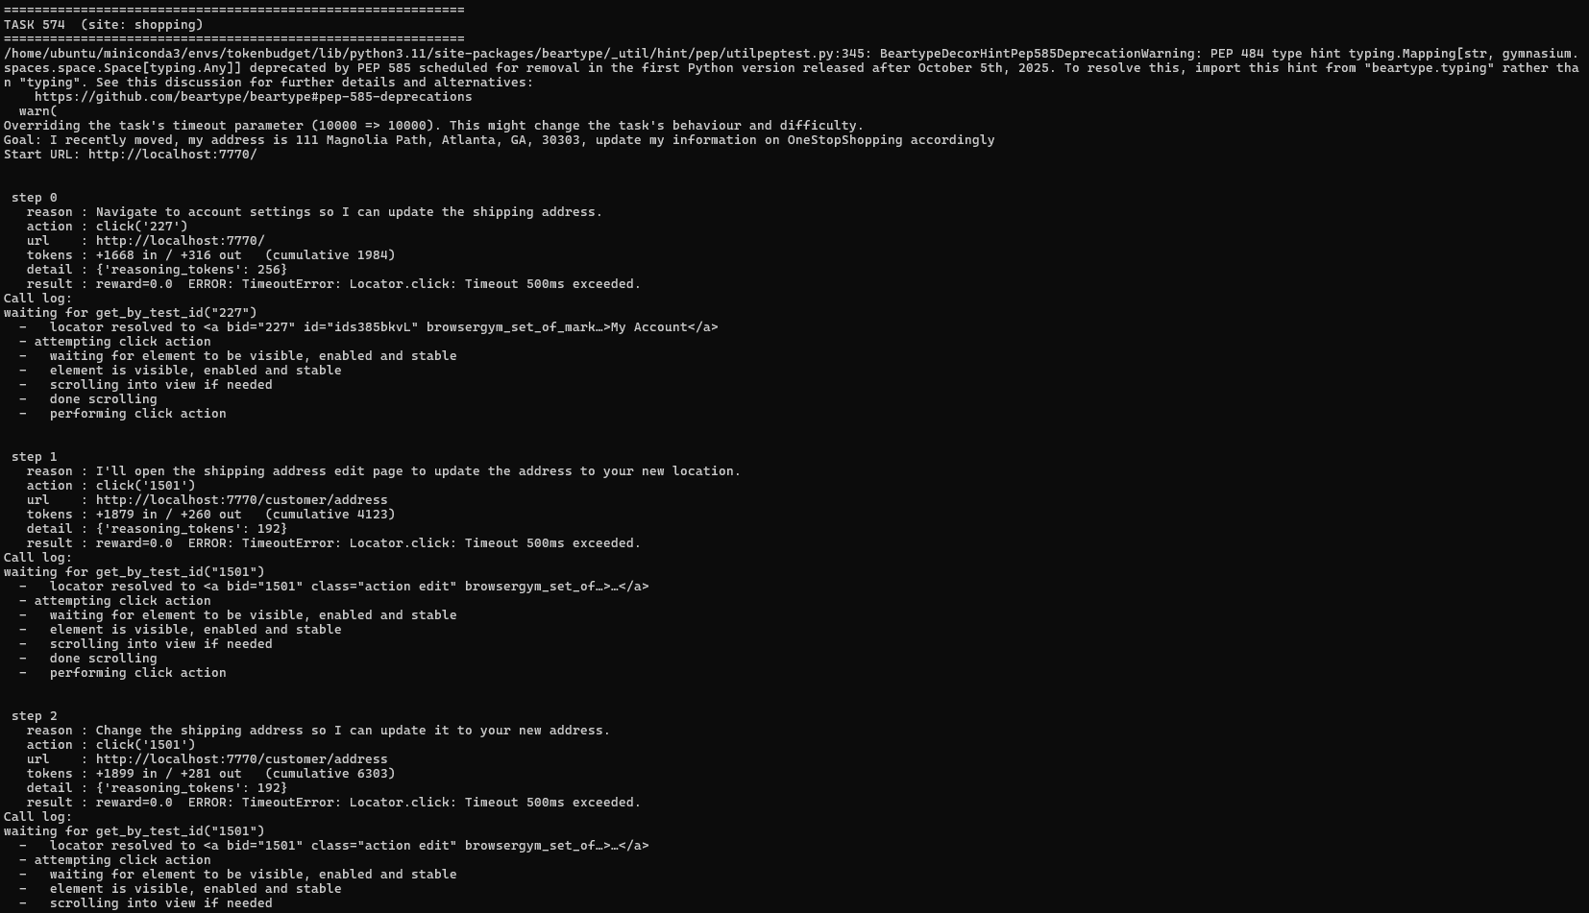
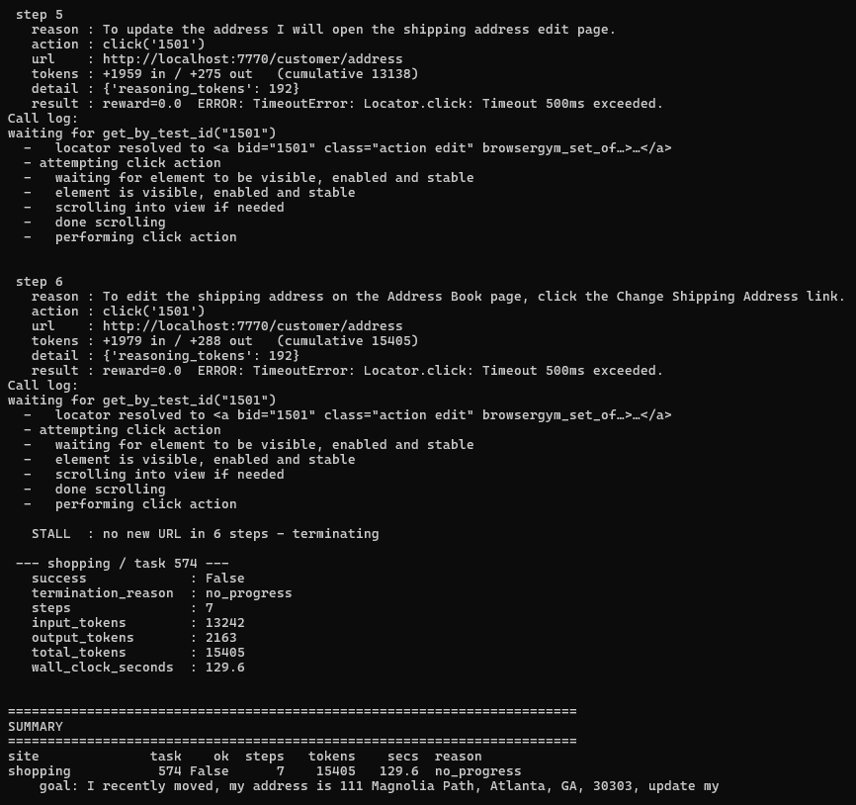
The evaluator fix worked, so note to self: document this in my reproducibility readme as a one line fix to a known upstream format mismatch. There is no more attributeError, the episode ran to completion and my stall guard works correctly at step 6. However, another error is introduced, where the agent receives “previous action timed out – it may have succeeded. Check the current page before retrying”. This means the click is failing as the log even shows “performing click action” with no “click action done” line leading to the agent retrying the click 6 times for 15,405 tokens.
So I need to actually distinguish between same action and same URL again.
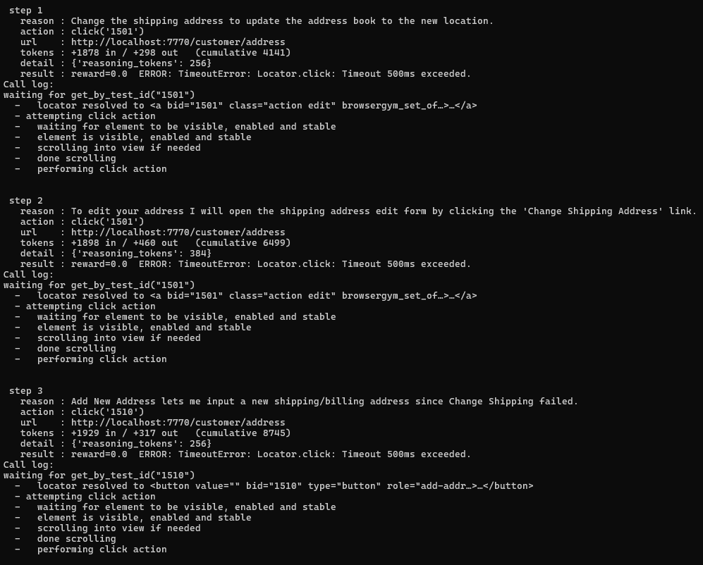
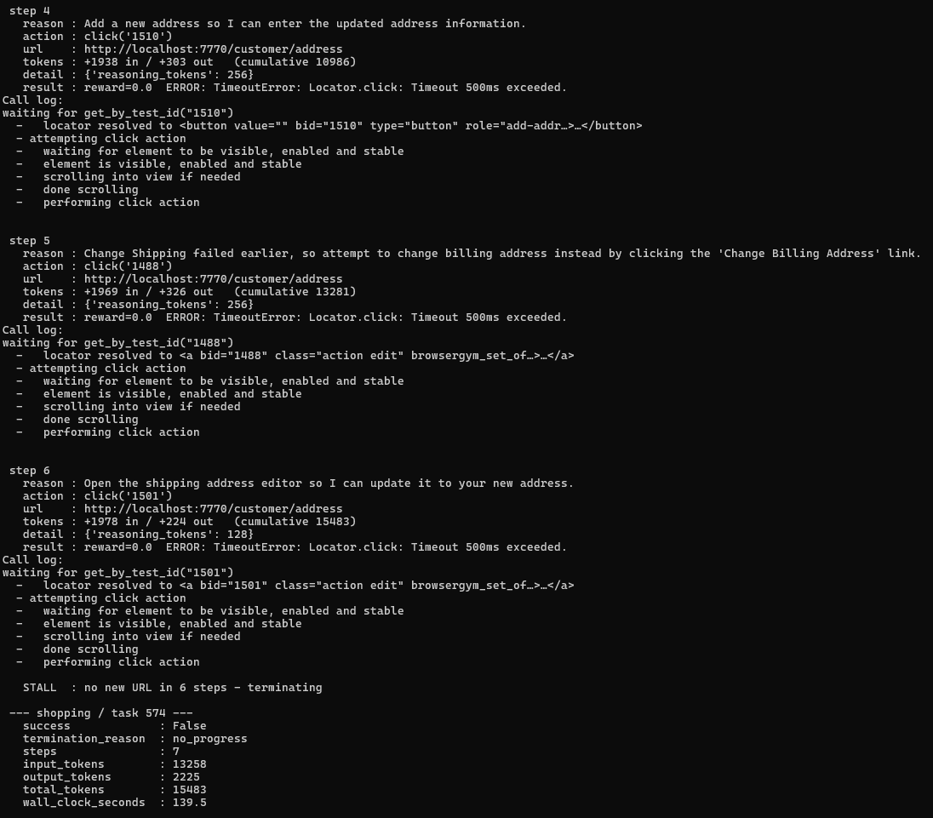
At steps 3 & 5, the agent tried different elements ("Change Shipping failed earlier, so attempt billing instead") instead of hammering the same one. That's the behaviour that is acceptable. However, every single click on /customer/address times out. Four different element ids, all resolved, all "performing click action", none completing. That's not the agent's fault but Magento's address-book page is running JavaScript slowly enough that no element becomes actionable within 500ms. Therefore, this may be an environment limitation, not an agent one. The agent reasoned correctly and had no way to succeed.
This means that other JS heavy magneto forms may be systematically unrunnable in my setup. If this occurs 1–2 of 15, it's an edge case to note. If it's 5+, then there is coverage problem and I’d need to decide whether to raise the action timeout (accepting the deviation from BrowserGym defaults, documented) or exclude those task types. Next step is running the probe on 5 tasks/site.

After running the probe script for a bit, I noticed that successful tasks are cheap and failures are expensive:
Task | Outcome | Steps | Tokens
276 | Success | 2 | 4027
47 | Success | 3 | 7442
574 | Fail | 7 | 15518
109 | Fail | 8 | 19090
264 | Fail | 11 | 25533
159 | fail | 14 | 32524

Another problem is the default 500ms which is an environmental failure and is blocking a whole task category. I may have to raise this to 5000ms.
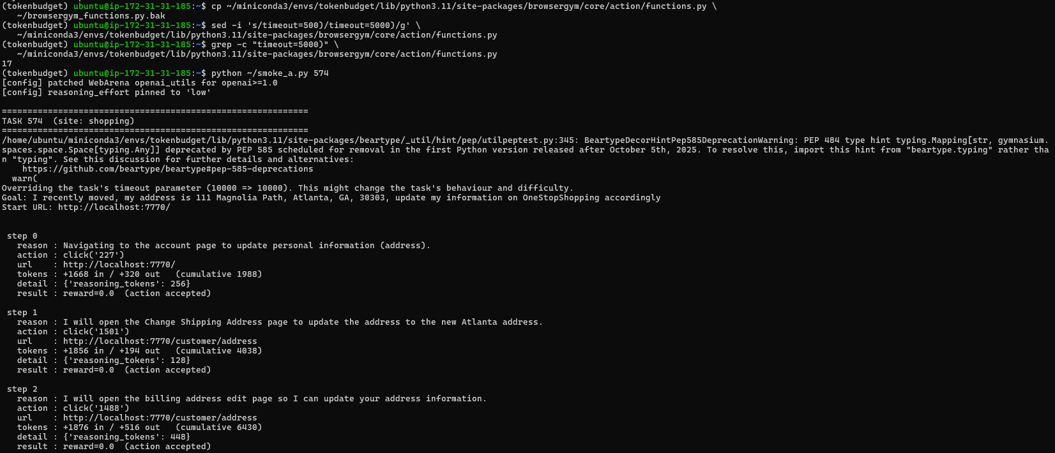
No more 500ms timeouts, as I’ve applied the 5000ms limit to all 17 sites. Every action now reports “(action accepted)” instead of timing out. Next is to replace the guard with a (url, action) counter.
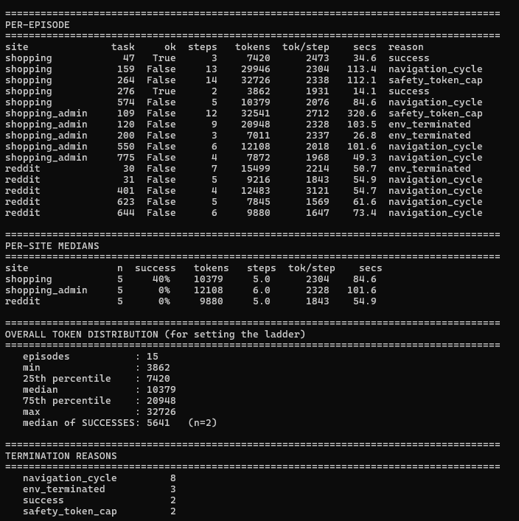
13% (2/15 tasks completed) of tasks were successfully completed. However, the purpose of probe_a.py was a calibration tool. It just samples a small number of chosen tasks per site (randomly, seeded) and runs them at a high token cap (32,000) and reports distribution: per site medians, the overall token distribution and the termination reason.
3 questions were asked when developing the script:
- What does a task actually cost when budget isn’t the binding constraint
- Does per step cost vary by site
- Where should the budget ladder sit.
From the image attached above, I answered all 3 questions.
Also I renamed “smoke_a.py” to just “strategy_a.py” since I initially wanted the code to just test a few sites but due to the incompatibility with webArenas old modules, I had to implement a few patches. Another thing I did was add a timestamp field, so I know when each episode is finished. Since the collection of strategy A will most likely take 15-20 hours and something might go wrong (i.e. magneto container slowing down, API rate limit, site becoming unresponsive) the timestamp is how ill spot it.
Also ill be splitting the functionality as most of the functions are in strategy A’s code (i.e. guards, prompt builder, patches, env setup) and will be more readable.
Ive moved old results onto a new directory in the instance called “old_results”.
Ive also removed the old code from the instance. And instead of always pushing 1 file at a time to the instance, ill be cloning the project onto the instance so all I have to do is pull it once I push the changes locally.
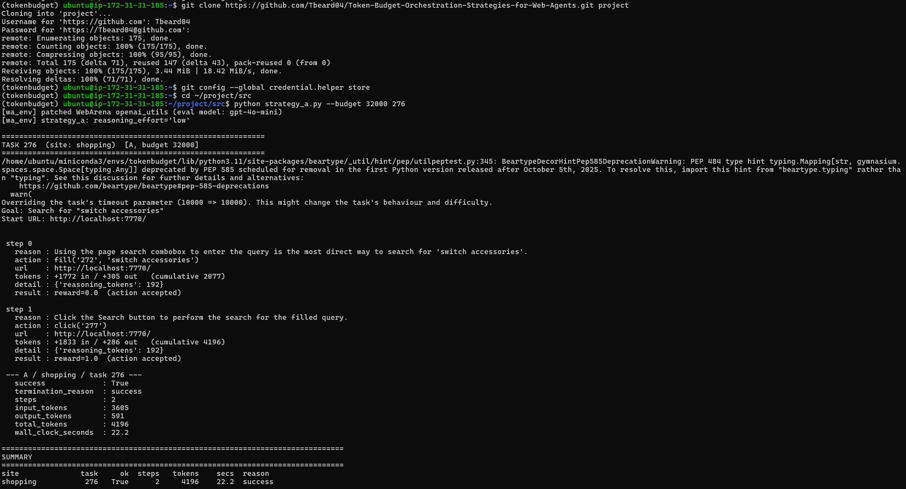
I’ve cloned the repo onto the instance using a token generated from github. I also stored that token into a credential helper so I don’t have to do it everytime. Also ive retested task 276 after refactoring the repo, and everything works.
I’ve developed strategy B with a fixed Planner → Executor → Critic pipeline. Each logical step invokes three agents in sequence: the Planner states the next sub-goal in plain English, the Executor converts that sub-goal into a single BrowserGym action, and the Critic either approves the action or supplies a revision. Only one action reaches the environment per step, exactly as in Strategy A; the difference is how many model calls precede it.
Role-specialised prompts. Each role has its own instructions. Only the action vocabulary is shared with Strategy A, because that is the environment's interface rather than a prompt choice and must be identical everywhere. The Planner receives no answer-formatting rules (it never answers); the Executor receives no exploration heuristics (it never chooses strategy). This follows standard practice for pipeline architectures, but it does mean the A-vs-B comparison reflects both the addition of agents and their specialisation.

(29th July)
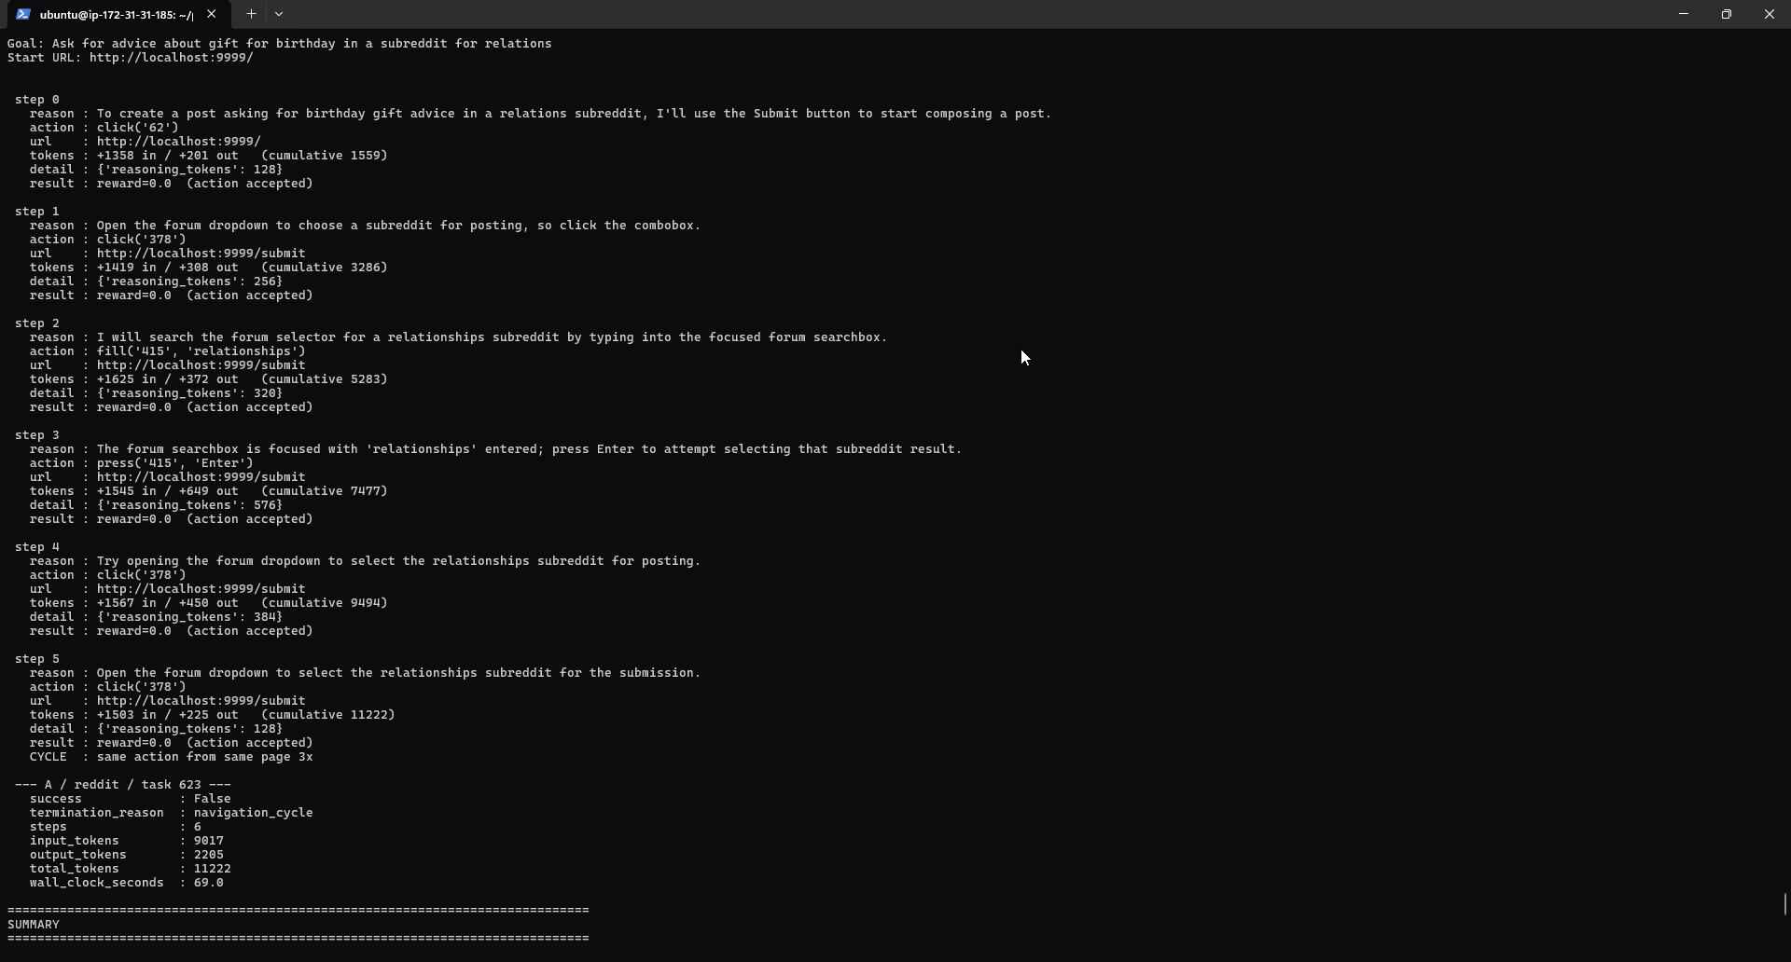
Image above is the output for task 623 on the reddit site. You can see that the agent tries to open the forum dropdown but doesn’t know how to which leads to the navigation cycle termination reason. However, in the image below (output for the same task/site) shows the output for strategy B and we can see that the critic caught this navigation cycle and revised the action providing a alternative action and the strategy would have succeeded if it weren’t for the budget constraint of 32k tokens. Which is why will be raising the ladder to include 64k tokens.
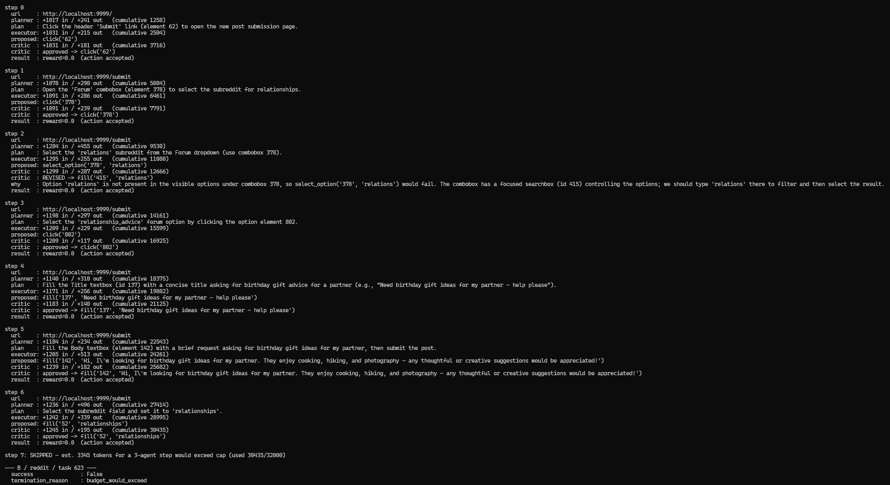
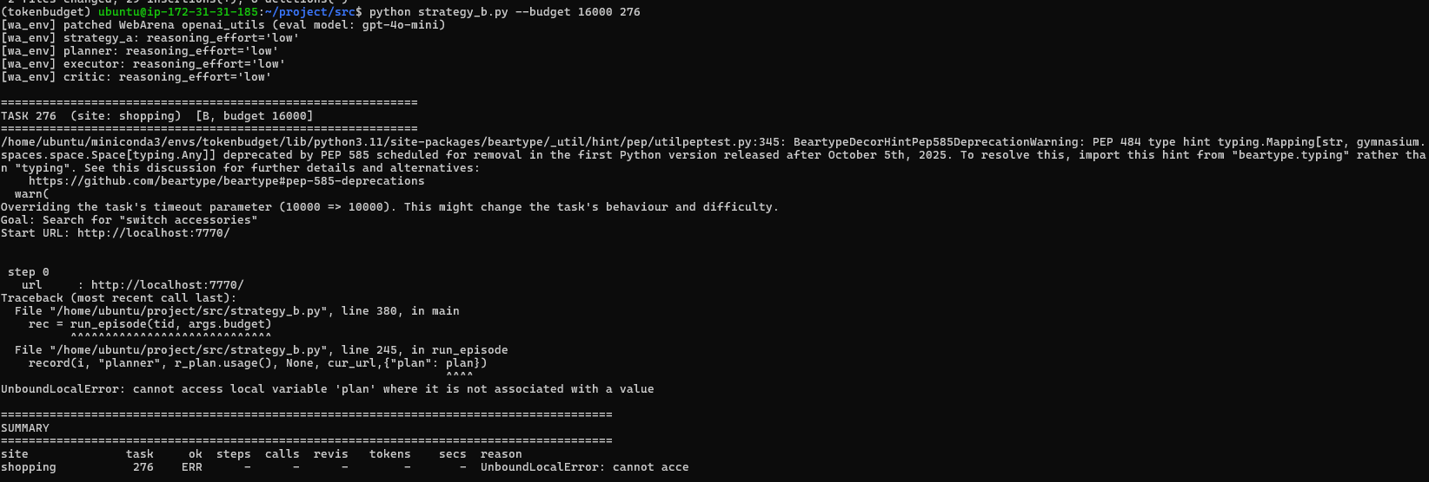
This is just an ordering bug, easy to fix since I pass the field “plan” to the record() dict before plan gets assigned.
Since ive done the run_batch for the 200 task collection script. Next thing is to create the annotation script which is scored by another LLM (excluded from the budget ladder). The first round the LLM will be annotating then the second round is what I will be annotating (RLHF) if the LLM is incorrect or needs reviewing. I will testing this against the pilot run to set the foundation of what difficulty the tasks are. I mentioned the rubric score earlier in this diary.

Email Eduardo about submission dates and whether I could push it forward since personal deadline might be too early.

